1
The Living World

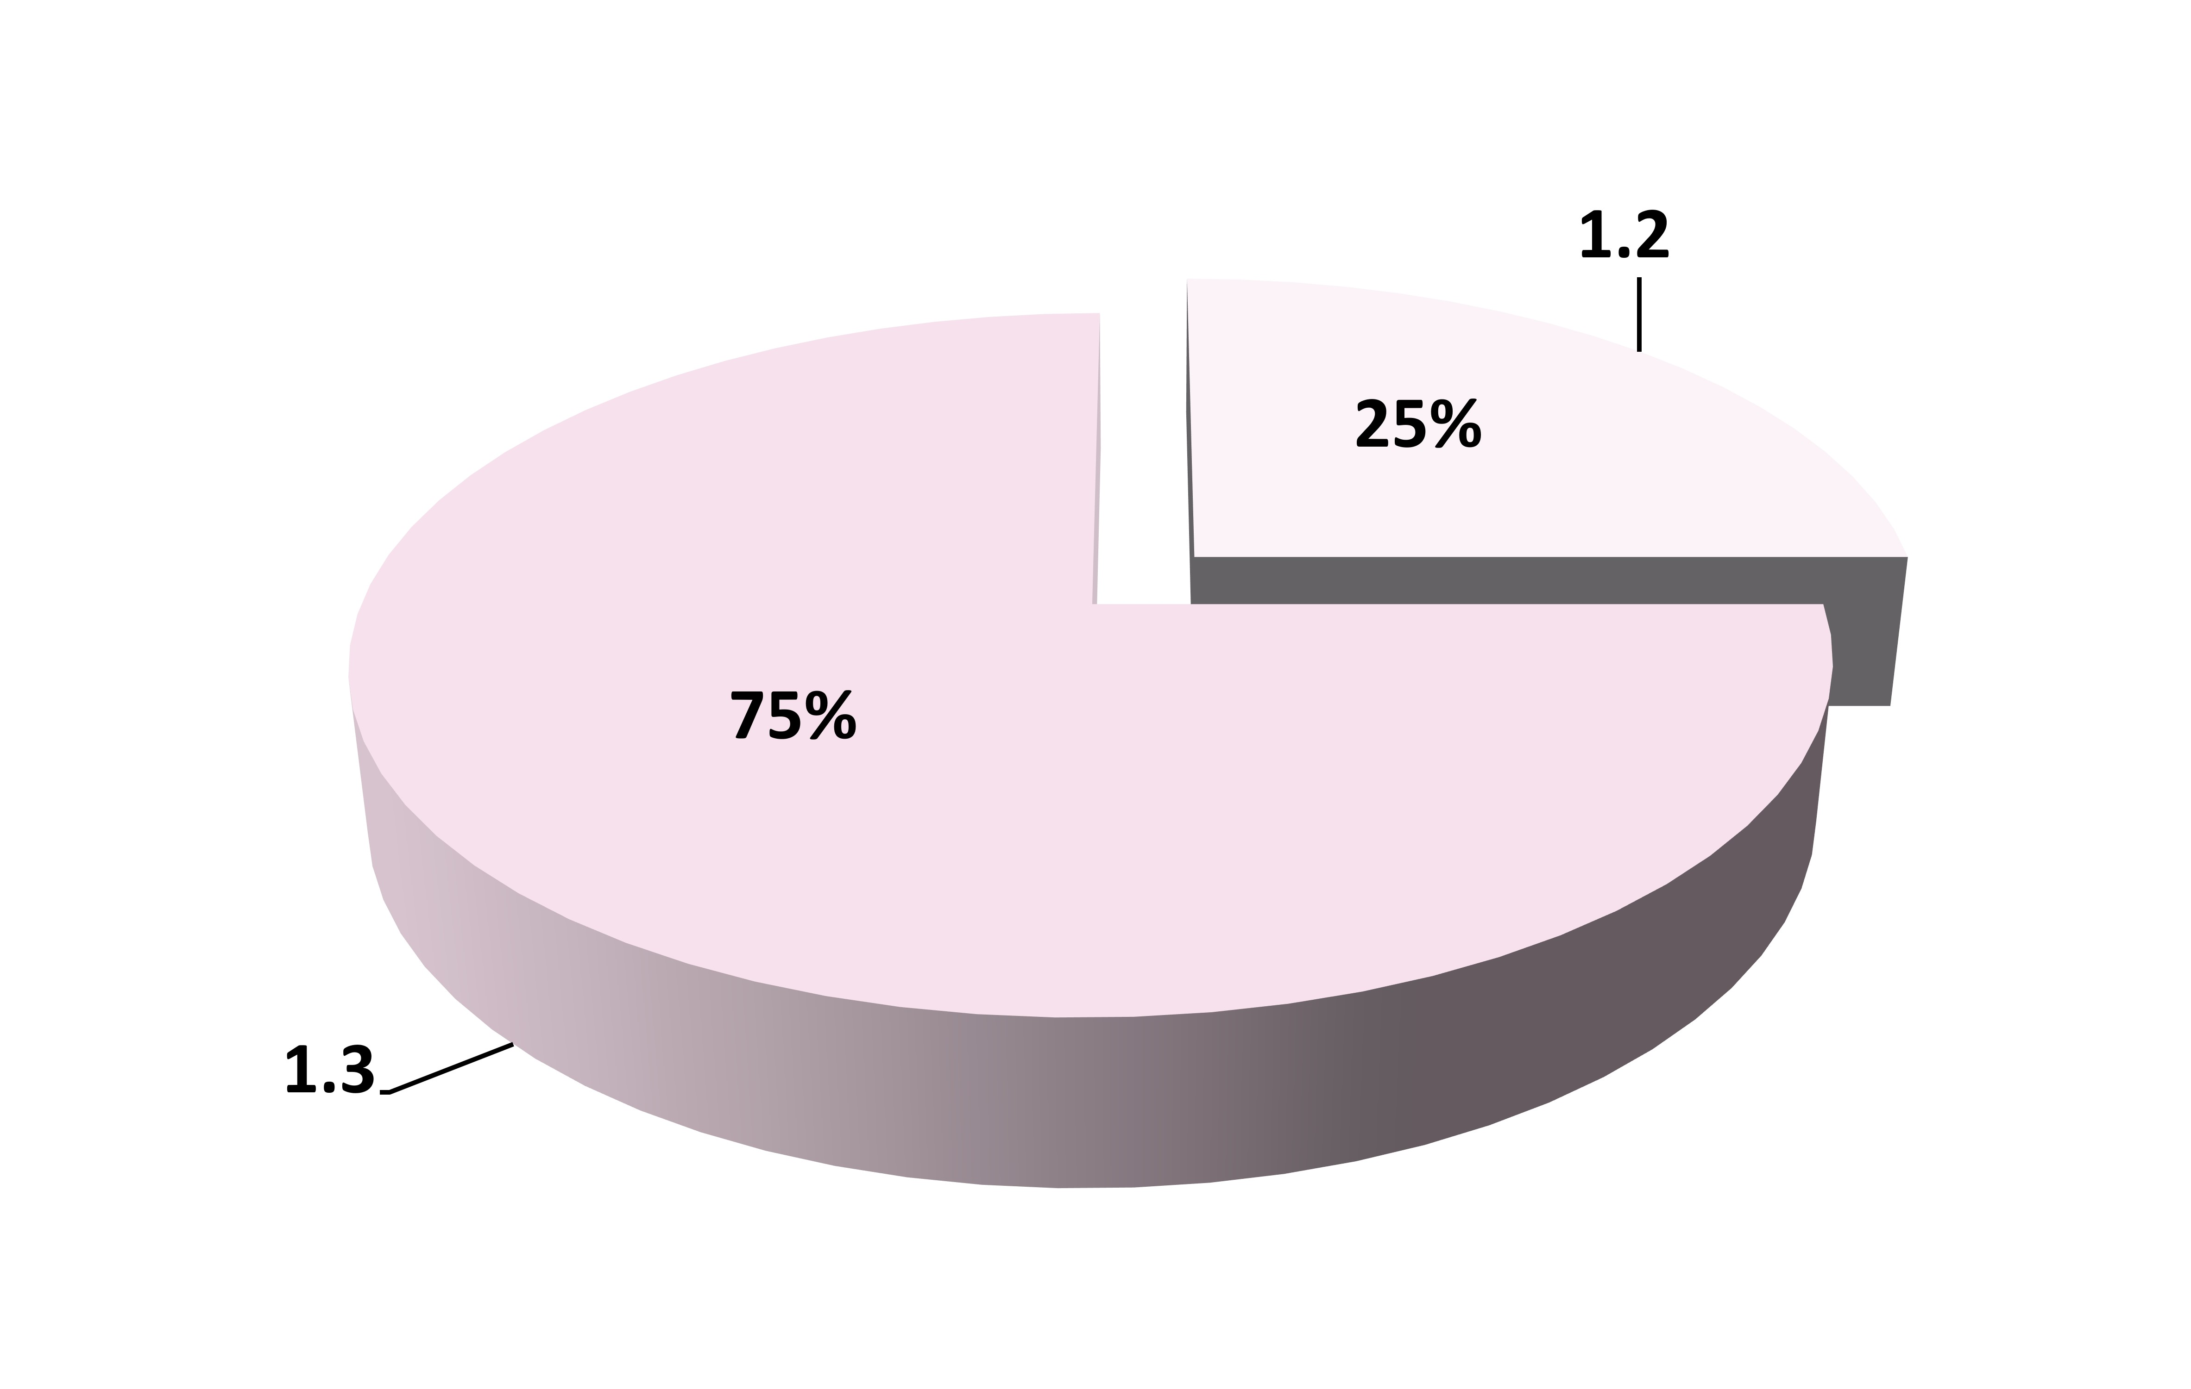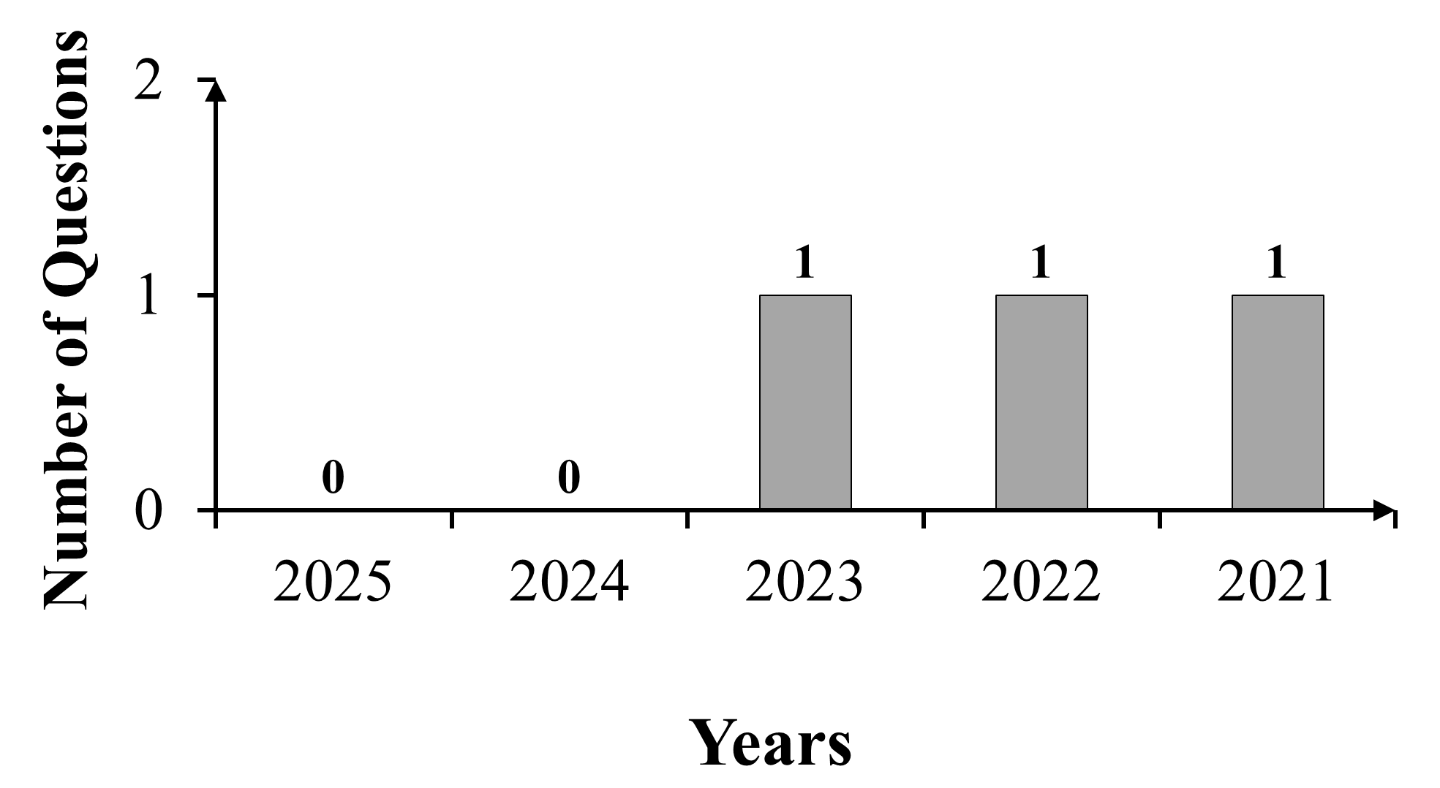

No. of Questions Asked in Previous Years

NEET(UG) Topic Trends
NEET (UG) Past 5 Years Analysis (2021-2025)

1.1 Diversity in the Living World

1.2 Taxonomic Categories

1.0 Introduction

1.a What is Living?
Chapter Outline

Synopsis

1.0 Introduction

Fundamentals of Biology and Taxonomy:
i. Biology: Study of life and living processes.
ii. Diversity: Vast variety of living organisms.
iii. Systematic Study: Enabled classification and taxonomy.

Ernst Mayr (1904–2004):
i. Title: “Darwin of the 20th century”
ii. Key Contribution: Defined biological species concept; emphasized species diversity
iii. Awards: Balzan Prize (1983), International Prize for Biology (1994), Crafoord Prize (1999)
iv. Lifespan: Lived 1904–2004 (100 years)

1.a What is Living?
Growth:

Feature | Living Organisms | Non-Living Objects
Definition | Growth is an internal process resulting from cell division. | Growth occurs due to accumulation of material on the surface.
Nature of Growth | Growth occurs from inside. | Growth occurs externally (by accumulation).
Mode of Growth | Occurs through cell division (mitosis). | Occurs through accumulation of material.
Continuity | Plants grow continuously; animals grow until maturity, with ongoing cell replacement. | Growth stops once material accumulation ceases.
Example | Growth of plants, animals, and unicellular organisms. | Growth of mountains, boulders, and sand mounds.
Reproduction:

Feature | Explanation
Definition | The process by which organisms produce offspring with features similar to their parents.
Sexual Reproduction | Common in multicellular organisms.
Asexual Reproduction | Fungi reproduce through asexual spores.
Budding | Observed in Yeast and Hydra.
Regeneration | Planaria exhibits true regeneration, where each fragment regrows missing parts.
Fragmentation | Some fungi, filamentous algae, protonema of mosses multiply by breaking into fragments.
Unicellular  Organisms | In unicellular organisms (e.g., bacteria, Amoeba), cell division results in both growth (increased size) and reproduction (new individuals).
Exceptions | Mules, sterile worker bees, and infertile human couples cannot reproduce.

Metabolism:
Definition: The sum of all biochemical reactions occurring in a living organism, encompassing catabolism and anabolism.

Key Points:
i. All living organisms are made up of chemicals that constantly undergo changes, forming new biomolecules.
ii. Metabolic reactions occur in all plants, animals, fungi, and microbes.
iii. Non-living objects do not exhibit metabolism.
iv. Metabolic reactions carried out in vitro are living reactions.

Cellular Organization:
All living organisms are composed of cells, either prokaryotic (lacking a nucleus) or eukaryotic (with organelles like the nucleus).

Consciousness:
Definition: The ability to sense and respond to environmental stimuli.

Key Points:
i. Humans are the most notably self-conscious organisms.
ii. Plants respond to external factors such as light, water, temperature, and pollutants.
iii. All living organisms (from prokaryotes to eukaryotes) respond to stimuli.
iv. Photoperiod (duration of light exposure) influences reproduction in many seasonal breeders (both plants and animals), demonstrating a response to environmental stimuli.


Consciousness:
Imagine you set an alarm on your phone. The moment it rings, you wake up and respond by turning it off.
i. Living organisms, like you, respond to stimuli (alarm).
ii. A rock won’t react, just like a switched-off phone won’t respond to a call!
iii. This ability to sense and respond is called consciousness – a defining feature of life.
Analogy



Characteristics of life can be categorized into two:
i. Defining properties: Metabolism, cellular organization, consciousness
ii. Non-defining properties: Reproduction, growth
Smart tip

1.1 Diversity in the Living World

Biodiversity: Approximately 1.7 million species are identified.

Identification: Process of recognizing and naming an organism based on its characteristics.

Nomenclature:
i. Standardized Naming Systems – Governed by internationally accepted codes:
a. International Code of Botanical Nomenclature (ICBN) for plants
b. International Code of Zoological Nomenclature (ICZN) for animals
ii. Binomial Nomenclature:
a. This naming system was given by Carolus Linnaeus.
b. Universal rules of binomial nomenclature are as follows:
1. Biological names are generally in Latin and written in italics (when printed) or underlined (when handwritten).
2. The first word is the genus name and the second word is the specific epithet.
3. The genus name starts with a capital letter and the specific epithet is written in small letters.
4. The author’s name, indicating who first described the species, follows the specific epithet.
e.g., Mangifera indica Linn. (Linn indicates that this species was first described by Linnaeus)

Classification: Systematic organization of organisms based on shared morphological, genetic, biochemical characteristics. Originating with Linnaeus’ Systema Naturae, it encompasses taxonomy (identification, naming, and hierarchical grouping) and systematics (elucidating evolutionary relationships to reflect phylogenetic history).

Scientific Names: In school, many students might have the same name – there could be two Rahuls in a class. But their roll numbers are unique.
i. Similarly, common names create confusion. For example, the domestic cat is called "Cat" in English, "Gato" in Spanish, and "Billi" in Hindi.
ii. To avoid this confusion, scientists use binomial nomenclature – a unique two-part Latin name for each species.
iii. The scientific name of a cat is Felis catus.
Analogy

1.2 Taxonomic Categories

i. Classification involves hierarchy of steps where each step represents a rank or a category.
ii. Taxonomic Category: A part of overall taxonomic arrangement.
iii. Taxonomic Hierarchy: All categories together constitute taxonomic hierarchy.
iv. Taxon (also known as rank): Unit of classification.
v. Organisms are classified into various categories based on their shared characteristics.

Taxonomic Category | Definition
Kingdom | The highest taxonomic rank, grouping all organisms into broad categories.
↓
Phylum (for animals) / Division (for plants) | A broad taxonomic category that groups multiple related classes. In animals, it is called a phylum, while in plants, it is called a division.
↓
Class | A taxonomic rank that includes related orders.
↓
Order | A group of related families sharing some characteristics.
↓
Family | A group of related genera with fewer common characters compared to genus and species. It is characterized based on vegetative and reproductive features.
↓
Genus | A group of related species which shows several common characters in comparison to species of other genera.
↓
Species | A group of individuals with morphological similarities, capable of interbreeding and producing fertile offspring.

Smart tip
Differences increase
←⎯⎯⎯⎯⎯⎯⎯⎯⎯⎯⎯⎯⎯⎯⎯⎯⎯⎯⎯⎯⎯⎯⎯⎯⎯⎯⎯⎯⎯⎯⎯⎯
Kingdom → Phylum/Division → Class → Order → Family → Genus → Species
⎯⎯⎯⎯⎯⎯⎯⎯⎯⎯⎯⎯⎯⎯⎯⎯⎯⎯⎯⎯⎯⎯⎯⎯⎯⎯⎯⎯⎯⎯⎯⎯→
Similarity increases

Organisms with their Taxonomic Categories:

Taxonomic Rank | Mango  (Mangifera  indica) | Potato  (Solanum  tuberosum) | Brinjal  (Solanum melongena) | Petunia  (Petunia spp.) | Datura  (Datura spp.) | Wheat  (Triticum  aestivum)
Species | indica | tuberosum | melongena | Petunia spp. | Datura spp. | aestivum
Genus | Mangifera | Solanum | Solanum | Petunia | Datura | Triticum
Family | Anacardiaceae | Solanaceae | Solanaceae | Solanaceae | Solanaceae | Poaceae
Order | Sapindales | Solanales | Solanales | Solanales | Solanales | Poales
Class | Dicotyledonae | Dicotyledonae | Dicotyledonae | Dicotyledonae | Dicotyledonae | Monocotyledonae
Division | Angiospermae | Angiospermae | Angiospermae | Angiospermae | Angiospermae | Angiospermae
Kingdom | Plantae | Plantae | Plantae | Plantae | Plantae | Plantae

[Note: Solanales is an order of flowering plants including plant families like Convolvulaceae and Solanaceae. Some older sources used the name Polemoniales for this order.]

In plants, classes with similar characteristics are grouped into a higher taxonomic category called a Division, which is equivalent to a Phylum in the animal kingdom.
CAUTION

Taxonomic Rank | Housefly  (Musca domestica) | Lion  (Panthera leo) | Leopard  (Panthera pardus) | Tiger  (Panthera tigris) | Cat  (Felis  catus) | Dog  (Canis lupus  familiaris) | Human (Homo sapiens)
Species | domestica | leo | pardus | tigris | catus | lupus familiaris  (subspecies) | sapiens
Genus | Musca | Panthera | Panthera | Panthera | Felis | Canis | Homo
Family | Muscidae | Felidae | Felidae | Felidae | Felidae | Canidae | Hominidae
Order | Diptera | Carnivora | Carnivora | Carnivora | Carnivora | Carnivora | Primata
Class | Insecta | Mammalia | Mammalia | Mammalia | Mammalia | Mammalia | Mammalia
Phylum | Arthropoda | Chordata | Chordata | Chordata | Chordata | Chordata | Chordata
Kingdom | Animalia | Animalia | Animalia | Animalia | Animalia | Animalia | Animalia

Name of the family usually ends with “idae” in animals and “aceae” in plants.
Smart tip


Mind Map


Defining Characteristics of Living Organisms
- Metabolism
- Cellular Organization
- Consciousness & Response to Stimuli

Taxonomy and Systematics
Taxonomy:
- Identification
- Nomenclature
- Claasification
Systematics: Incorporates taxon- omy and the study of evolutionary relationships

The Living World
Binomial Nomenclature
(Carlous Linnaeus)
- Consists of: Genus and species name
- Universal Naming Rules (ICZN and ICBN)
Taxonomic Hierarchy
- Kingdom → Phylum (for animals) /Divison (for plants) → Class → Order → Family → Genus → Species
Diversity in the Living
World
- Number of species identified: About 1.7 million

Glossary

1. Taxonomy: The branch of biology that deals with the identification, nomenclature, and classification of organisms based on their characteristics and diversity.
2. Biodiversity: The variety of life forms on Earth, including species diversity, genetic variation, and ecosystem diversity.
3. Catabolism: The set of metabolic processes that break down complex molecules into simpler ones, releasing energy (e.g., digestion of food into smaller components).
4. Anabolism: The set of metabolic processes that build larger, complex molecules from simpler ones, requiring energy (e.g., synthesis of proteins from amino acids).

Mnemonics

1. Taxonomic Hierarchy: Kids Prefer Candy Over Fried Green Spinach
K – Kingdom, P – Phylum, C – Class, O – Order, F – Family, G – Genus, S – Species

